Linux exercise 3 - Filesystem

- List only directories and one level from Linux root directory.

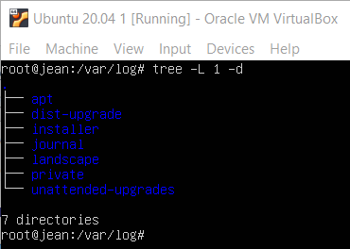

- List /var/log directory content with two levels and full path prefix for each file.
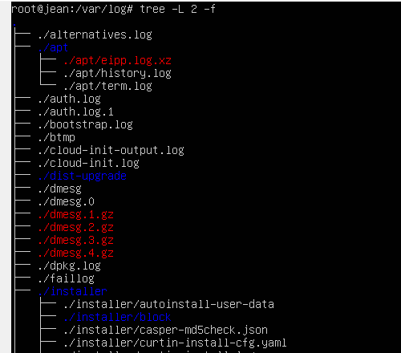
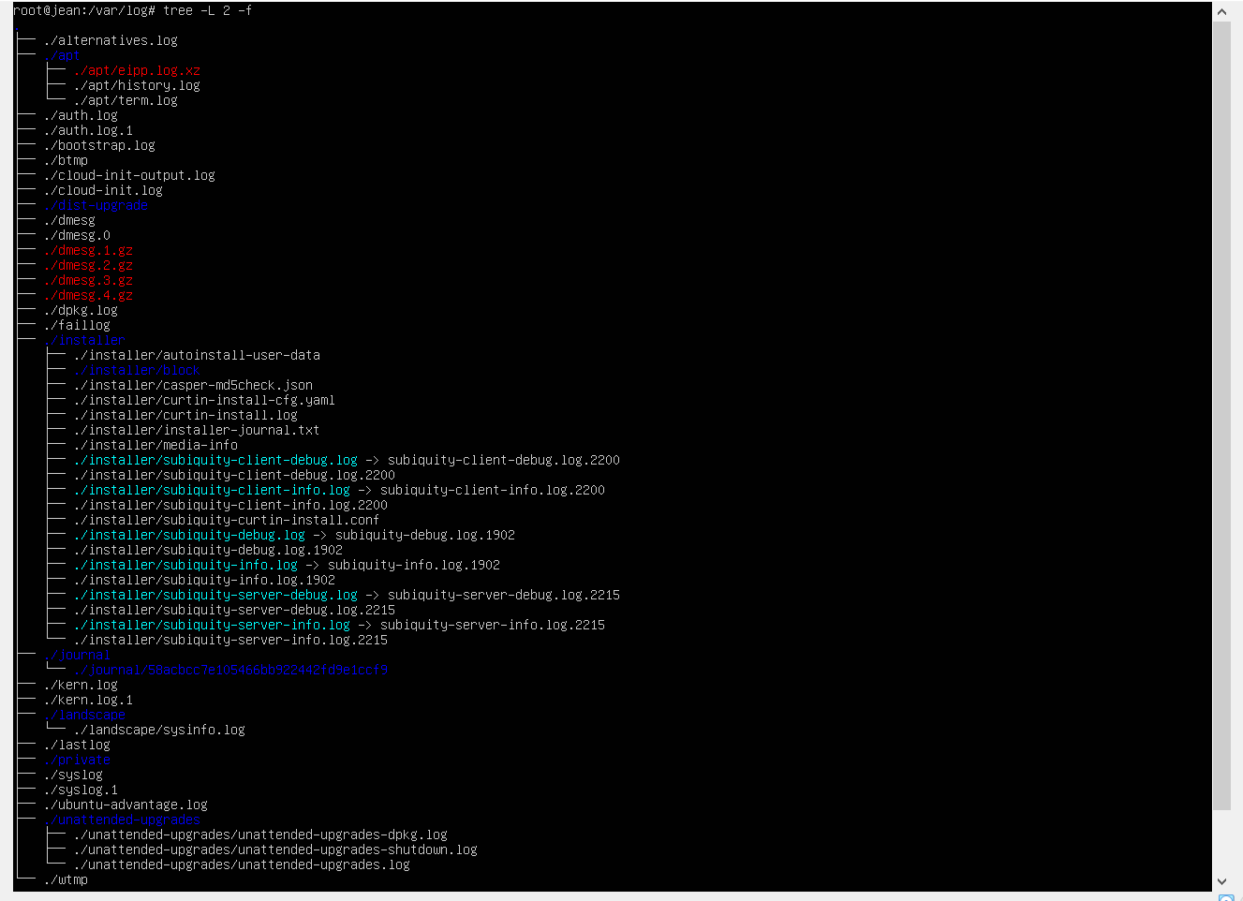
- List /bin directory content with owner information, size in human readable format and name starting with 'xs'.
